Quiz#11
Section: __________________________ Group: _______________________
Name(print): ______________________________ Student ID: _________________________
- On a frictionless horizontal tabletop, a small ball with a mass of 0.15 kg is moving toward the center of a slender rod with a length of 2.30 m at the speed of 3.80 m/s. One end of the rod is fixed. What is the angular momentum of the small ball right before it hits the rod (out of the screen is defined to be the positive direction)?
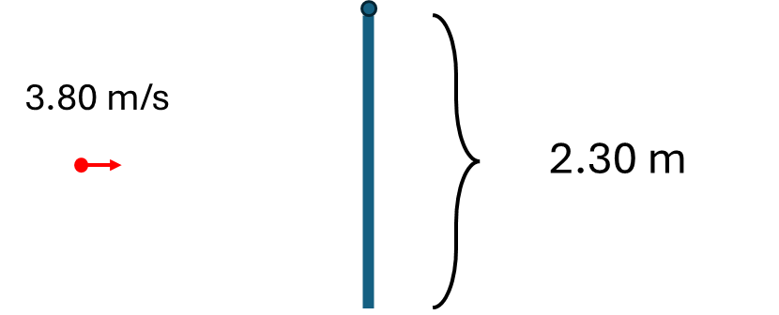
- 1.31 kg∙m²/s
- -1.31 kg∙m²/s
- -2.62 kg∙m²/s
- 0.656 kg∙m²/s

- A uniform circular hoop with a radius 4.5 cm rolls without slipping down a ramp inclined at an angle of 25° to the horizontal. Use a five-step problem-solving procedure to determine the hoop's angular acceleration. In the diagram step, include a free-body diagram illustrating the forces acting on the hoop (Hint: the demo in class showed that a cylinder rolls down faster than a hoop. The tutorial problem showed the linear acceleration of a cylinder is $\frac{2}{3}g\sin{θ}$).



